Media Statement

S. Korea’s proposed 2030 emissions target falls disappointingly short of Paris goals

Falling short of international expectations, the Korean government announces an interim 2030 emissions target of 40% below 2018 levels. Seoul-based NGO Solutions for Our Climate points out that the provisional target is still very insufficient to meet Paris Agreement goals and irresponsibly relies on overseas reductions.

October 8 – On Friday morning, the Korean government revealed a provisional emissions target of 40% reduction below 2018 levels by 2030 or 436.6 million tons CO₂ equivalent (MtCO2e) by the end of the decade. Of this value, an approximate 10% reduction relies on international offsets, carbon sinks and carbon capture and storage.

The interim Nationally Determined Contribution (NDC) follows discussions between the government and public-private Presidential Committee on Carbon Neutrality. Since the release, civil society groups have been protesting that the target is hardly an enhancement of the previous NDC (26.3% reduction below 2018 levels), which was already found “highly insufficient.”

In response to the announcement, Joojin Kim, managing director of Seoul-based research and advocacy group Solutions for Our Climate, said:

"Korea’s proposed emissions cut of 40% remains seriously inadequate to meet global climate goals. Korea needs at least a 59% domestic reduction in emissions below 2017 levels by 2030 to do its fair share under the Paris Agreement.¹

Korea is lagging behind many advanced economies committing to at least halving their emissions by the end of the decade. Japan proposed to reduce emissions by up to 50% below 2013 levels, and Germany by 65% below 1990 levels, by 2030.

The provisional NDC also does not prioritize domestic emissions reduction, and instead relies heavily on international offsets, which would more than double compared to the existing target.² The Korean government has received criticism for its reliance on overseas carbon offsets in the past, and it’s questionable whether international reductions will be feasible at a time when countries around the world are working to strengthen their NDCs.

Further, the carbon sequestration goal from forestry needs re-examination due to incomplete forest carbon statistics and concerns regarding double counting of emissions reduction from biomass usage raised by environmental groups.

Korea must focus on domestic emissions reduction by minimizing its reliance on coal power and requiring further emissions cuts from the power generation and industrial sectors. The interim target still allows for coal power to account for 21.8% of electricity generation in 2030, which ignores the call for OECD countries to phase out coal by the end of the decade.

Ultimately, the proposed 40% emissions reduction target comes down to 30% in domestic emissions reduction below 2018 levels – which can hardly be called an ‘enhancement.’

Especially with Korea’s candidacy to host COP28, the Moon administration must make a bolder NDC commitment before COP26 in November.”

ENDS.

Solutions for Our Climate (SFOC) is a South Korea-based group that advocates for stronger climate change policies and transition towards a fossil-free society. SFOC is led by legal, economic, financial, and environmental experts with experience in energy and climate policy and works closely with policymakers.

Notes

- As revealed in a 2020 study by Climate Analytics, Transitioning towards a zero-carbon science-based emissions reduction pathways for South Korea under the Paris Agreement, a Paris-compatible domestic NDC for South Korea would require at least a 59% domestic reduction in emissions below 2017 levels by 2030 (291 MtCO2e). The overall NDC target in the graph below notes the not-yet-enhanced NDC of 24.4% reduction in emissions below 2017 levels by 2030 (539 MtCO2e).

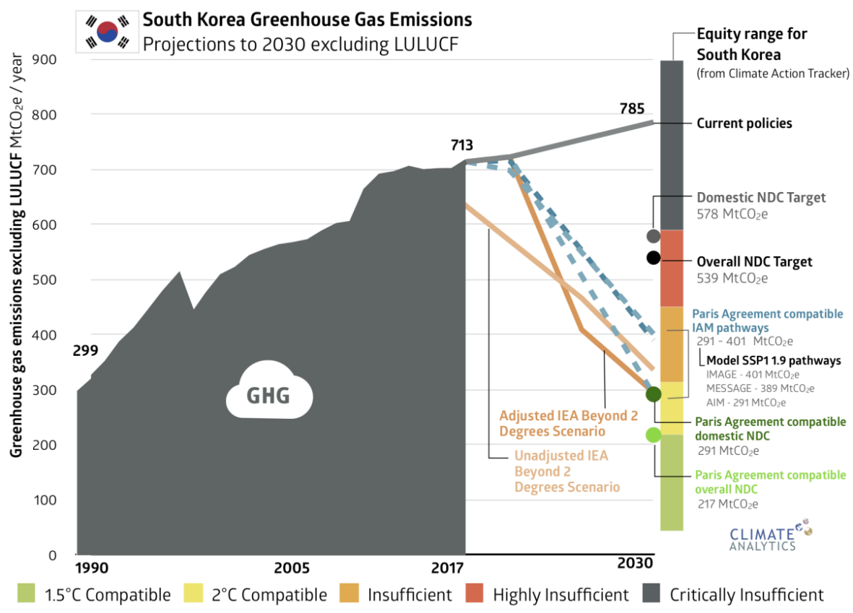

- Korea’s provisional target calls for 35.1 MtCO2e reduction in emissions through overseas offsets, 10.3 MtCO2e in reduction through CCUS technology, and 26.7 MtCO2e in reduction through carbon sinks. The previous target assumed 16.2 MtCO2e, 10.3 MtCO2e, and 22.1 MtCO2e, respectively. Figure below from the Online 2030 NDC Discussion materials.

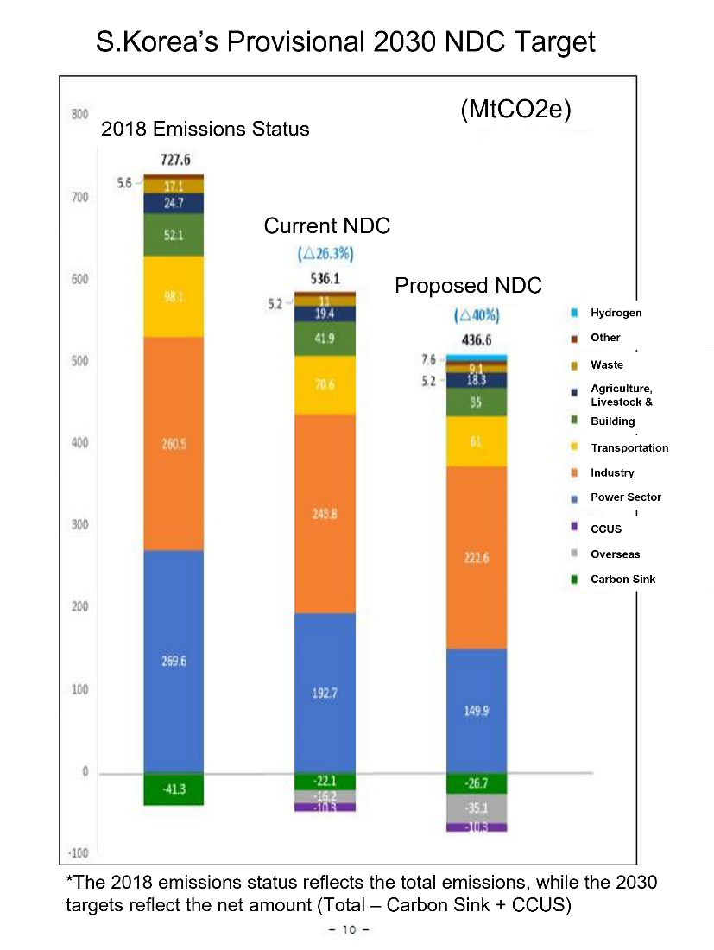

For media inquiries, please reach out to:
Euijin Kim, Communications Officer, Solutions for Our Climate, euijin.kim@forourclimate.org

