Press Release

Despite bid to host COP28, S. Korea comes empty-handed to its own global sustainability summit

President Moon announces bid for COP28 candidacy at the Partnering for Green Growth and the Global Goals 2030 (P4G) Summit with no enhanced Korean climate or energy targets, drawing criticism from civil society.

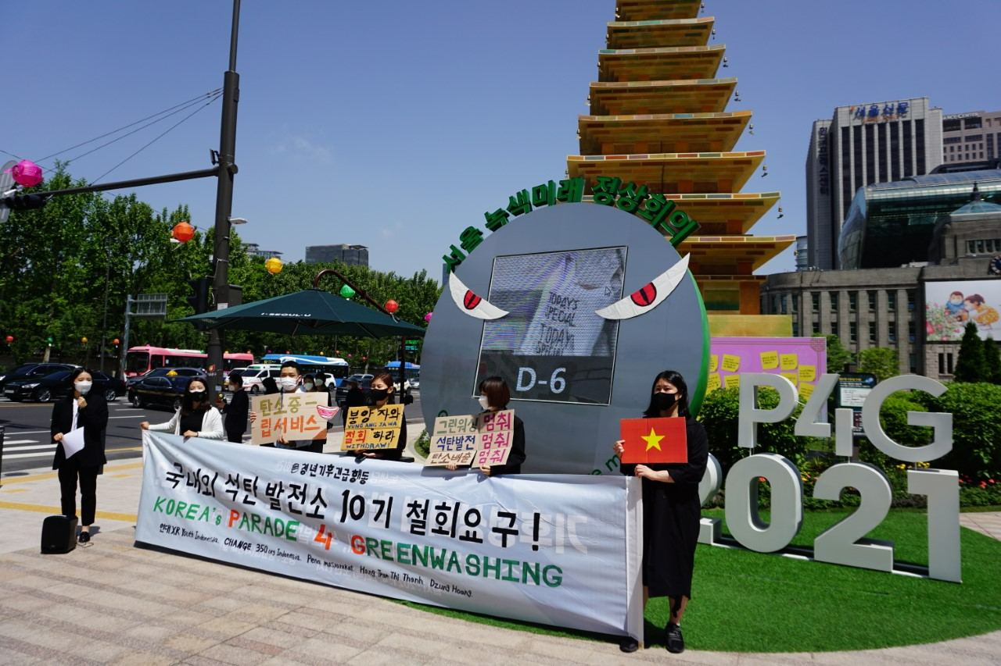
Youth Climate Emergency Action protests in front of the P4G 2021 sign in Seoul Plaza to criticize the Korean government’s greenwashing of the summit and urge immediate withdrawal from overseas coal investments and cancellations of new domestic coal power projects.

Seoul, May 31, 2021 – Undermining South Korea’s newly announced bid to host the 28th United Nations Climate Change Conference of the Parties, or COP28, in 2023 at the 2021 Partnering for Green Growth and the Global Goals (P4G) Summit in Seoul, President Moon presented no new concrete domestic climate commitments to back the country’s candidacy. Bucking the summit’s theme of “carbon neutrality” and attendance by world leaders including US climate envoy John Kerry, UK Prime Minister Johnson, French President Macron, and German Chancellor Merkel, Korea decided to idle at its Nationally Determined Contribution (NDC) target of 24.4% emissions reduction below 2017 levels aligned with catastrophic warming scenarios.

While postponing the finalization of an enhanced NDC to this year’s COP26 in November, President Moon officially announced Korea’s bid to host COP28 in 2023. He also shared Korea’s plan to contribute US$4 million in new grants to P4G operations and establish a US$5 million “Green New Deal” fund at the Global Green Growth Institute (GGGI) as part of the country’s efforts to tackle climate change and economic growth. The Seoul Declaration (attached) announced on Monday merely called for more public-private partnerships on UN Sustainable Development Goals.

On the lack of advancement from previous commitments at the Leaders’ Summit on Climate last month and U.S.-Korea Bilateral held ten days before the summit, Joojin Kim, Managing Director at Solutions for Our Climate, said:

“Korea lost a valuable opportunity to demonstrate climate leadership at this year's P4G Summit. The country could have presented enhanced NDC, coal phase-out, and renewables targets -- all of which could have helped Korea show its sincerity in hosting the COP28 in 2023 -- but instead chose to reiterate existing policies.

The science has continuously highlighted the urgent need for Korea to raise its NDC target. To be 1.5˚C-aligned, the country needs a target of 59% below 2017 levels. The IEA calls for coal phase-out by 2030 and the decarbonization of the power sector which represents 36% of total national GHG emissions by 2035 in OECD countries such as Korea.

Coal phase-out before 2030 would save $5.5 billion under a carbon-neutral scenario and can prevent more than 18,000 premature deaths across East Asia.”

During the two-day summit, which engaged partner countries such as Indonesia and Vietnam that host some of Korea’s overseas coal power projects, President Moon also stressed the importance of Korea playing the bridge role between developing and advanced nations. He shared plans to increase official development assistance (ODA) associated with climate and green projects by 2025. Contrary to this ambition, Korea committed US$710 million to the Vung Ang 2 coal power project in Vietnam and US$1.4 billion for Jawa 9, 10 project in Indonesia last year. The new project investments made before the Korean pledge to end overseas coal funding at the Leaders’ Summit on Climate last month have not been called off or modified.

There were high expectations for Korea to enhance its climate and energy targets at the home-ground event. By announcing to cut emissions by 46% - 50% by 2030 last month, neighboring Japan joined the “50 percent club” of countries committed to cut their emissions at least by half by 2030 – along with the United States, European Union, and United Kingdom. At the Leaders’ Summit on Climate, President Moon pledged to enhance Korea’s NDC by the end of the year. Weeks before the P4G Summit, former US Vice President Al Gore wrote a letter to President Moon asking to raise Korea’s NDC target to at least 50% under 2017 levels by 2030 to remain consistent with a Paris-aligned, 1.5˚C pathway. US climate envoy John Kerry also urged the country to double its current NDC and phase out coal early, to which Korea pledged to announce the enhanced NDC target by early October. On Sunday, UN Secretary-General António Guterres urged Korea to follow through with its Green New Deal by announcing a coal phase-out plan and an enhanced NDC in line with its long-term goal, and increase international support for adaptation, renewables, and sustainable development. Despite these calls, President Moon on Sunday deferred the finalization of Korea's NDC to COP26 in November.

Earlier today, the climate envoys of Denmark and the Netherlands, Korea’s partner countries in the P4G, published an op-ed calling on Korea to decarbonize its power system in the 2030s and to take concrete steps at the P4G Summit to align with efforts to limit global warming to below 1.5°C as an OECD country.

Civil society has also been pressuring the Moon administration to take bold climate actions. Weeks before the summit, the Korea Beyond Coal network demanded at least a 50% reduction of emissions below 2010 levels and a complete coal phase-out by 2030. A youth climate activist undertook a hunger strike in front of the summit venue to protest against the government’s inaction while it calls for individual actions such as recycling from Korean citizens.

Eunbin Kang of Youth Climate Emergency Action, took issue with the corporate greenwashing at the event:

“The Korean youth feel ashamed of our own government failing to cancel domestic and overseas coal power projects and then greenwashing corporations as leading action takers in combating the climate crisis, while they are the villains behind the country’s high level of greenhouse gas emissions. To do it at such a symbolic international stage like P4G cannot be excused.

The root cause of the problem cannot be the solution. The Korean government is only promoting individual actions like using tumblers over disposable products. Instead of arguing over individual ethics in reaching carbon neutrality by 2050, the government must impose stronger regulations on corporations and their social responsibilities.”

ENDS.

Solutions for Our Climate (SFOC) is a South Korea-based group that advocates for stronger climate policies and reforms in power regulations. SFOC is led by legal, economic, financial, and environmental experts with experience in energy and climate policy and works closely with policymakers.

Youth Climate Emergency Action (YCEA) is a youth coalition group launched in January 2020 in the face of an immediate climate crisis threat imposed upon human civilization. To overcome the climate crisis and inequality as a task of the times, YCEA leads social movements in solidarity with various stakeholders in civil society.

For media inquiries, please contact:
Jeeyeon Song, Communication officer, jeeyeon.song@forourclimate.org

