PRESS RELEASE
S. Korean coal phase-out by 2029 could save over 18,000 lives, study reveals

Air pollution from coal plants in South Korea is expected to lead to 23,000 premature deaths both domestically and overseas until 2054. An early coal phase-out plan by 2030, however, could prevent at least half of early deaths in the next five years, a new study finds.

May 12, 2021 – In South Korea, phasing out coal before the end of the decade could save more than 18,000 lives – around 12,600 domestic and 5,800 abroad -- including in China, Japan, and North Korea – from premature death when compared to the 2054 coal phase-out scenario under current policy, according to new analysis from international climate research organization Climate Analytics.

Still heavily reliant on coal power, South Korea hosts 56 coal power plants that generate approximately 40% of the nation’s electricity. However, despite the country’s 2050 carbon neutrality pledge last October, the Korean government has yet to announce an official coal phase-out year. The relatively young 35GW Korean coal fleet accounts for 30% of national CO2 emissions and 11% of fine particulate matter (PM2.5) pollution.

Air pollution in South Korea has grown at an alarming level, with the PM2.5 concentration in recent times almost doubling recommended limits put forth by the World Health Organization (WHO), making the Korean government declare it a “social disaster.” Fuel combustion, including coal burning, is a significant source of PM2.5, and fine dust pollution is linked to premature deaths due to increased risk of cardiovascular disease, chronic and acute respiratory diseases, lung cancer, and other health impacts such as preterm births and depression.

The new analysis, following a previous study which showed South Korea would need to phase out coal before 2030 to be Paris Agreement-compatible, presents two coal decommissioning schedules based on each coal power unit’s carbon emissions-intensity and generation cost, respectively. The different criteria for ranking retirement priority made only a slight difference in the number of lives saved with both decommissioning schedules requiring 4.2 gigawatts (GW) of coal capacity to close each year.

“This analysis clearly demonstrates there are health as well as climate gains for South Korea pursuing a 2030 coal phase-out to meet the Paris Agreement’s goal of limiting temperature rise to 1.5°C,” said Bill Hare, chief executive of Climate Analytics. “We find this would reap immediate benefits: with premature deaths linked to air pollution from coal halving in the next five years.”

Nevertheless, seven new coal power units of 7.3 GW are still under construction in the country. The latest coal fleet plan includes the controversial 2,100 MW Samcheok Blue Power1 project, the last domestic coal power project in South Korea. Under the 9th Basic Plan for Electricity Power Supply and Demand2 released last December, over 27 GW of coal power capacity will still be online in 2034, with coal eventually being phased out in 2054 if new coal power projects are operated.

“The market-based decommissioning schedule in the study is important, because the data shows that plants under construction, including Gosung Hai 1&2, Gangreung Anin 1&2, Samcheok Blue Power 1&2 and Shinseocheon would have to retire almost immediately after completion,” said Jeehye Park, the coal program director, at Solutions for Our Climate, a Korea-based NGO, one of the contributors to the new report. “With the dim future of coal already predicted, going forward with physically detrimental projects, taking away people’s health and expected lifetimes seems ethically wrong.”

The study found that the most affected municipalities in terms of deaths per population under the assumption of all units being online at the same time, include areas like Samcheok, which plans to host two new coal power plants. When summed up, approximately 430,000 years of potential life will be lost due to air pollution from South Korea’s coal power fleet under current policies – 280,000 years of the domestic residents and the remaining 140,000 of those living abroad. On the other hand, either of the Paris-compatible coal power decommissioning scenarios presented in the study could save more than 330,000 life years in total between 2021-2054. In addition to the premature deaths, the report also found that a Paris Agreement-aligned coal phase-out plan could reduce over 1,700 preterm births and 3,000 new asthma cases.

ENDS.

Solutions for Our Climate (SFOC) is a South Korea-based group that advocates for stronger climate policies and reforms in power regulations. SFOC is led by legal, economic, financial, and environmental experts with experience in energy and climate policy and works closely with policymakers.

Climate Analytics is a non-profit climate science and policy institute based in Berlin, Germany with offices in New York, USA, Lomé, Togo and Perth, Australia. It seeks to empower those most vulnerable – Small Island Developing States and Least Developed Countries – to use the best science and analysis available in the international climate negotiations, as well as in developing policies and institutional capacity to adapt to climate change. Climate Analytics undertakes extensive research on the 1.5°C temperature limit in the Paris Agreement, evaluates progress on climate action and shows governments how they can act on their policies to keep global warming to this limit.

Notes

1. The 2,100 MW Samcheok Blue Power project accounts for two of the seven new coal power units currently under construction in South Korea.
2. The Basic Plan for Electricity Power Supply and Demand is a biennial national power plan prepared by the Ministry of Trade, Industry and Energy on a 15 year-term. The last plan was released in December 2020.
3. Figures 1 & 3
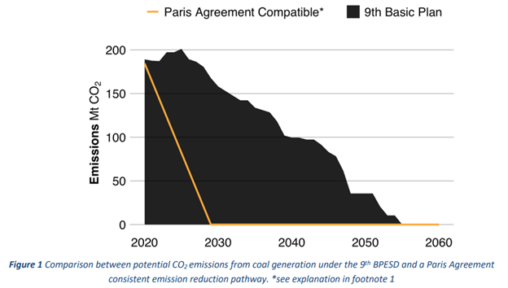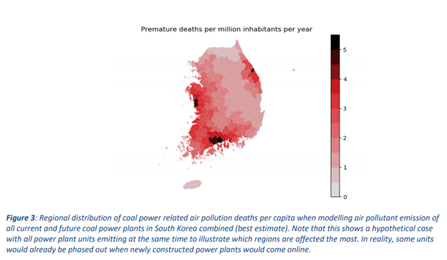
For media i﻿nquiries, please reach out to:
Jeeyeon Song, Communication officer, jeeyeon.song@forourclimate.org

