PRESS RELEASE
S. Korean gas giant SK E&S sued in a landmark case over greenwashing

In the first-ever legal action in South Korea brought against a company on its greenhouse gas emissions, the country’s largest private LNG provider SK E&S is being accused of greenwashing its gas development project off the northern coast of Australia as “CO2-Free” LNG.

December 22, 2021 - Environmental group Solutions for Our Climate is taking legal action against South Korean energy giant SK E&S over the corporation’s alleged greenwashing of its gas business through the Korea Fair Trade Commission and the Ministry of Environment.

The legal challenge comes amid a wave of similar actions against global oil and gas companies. Earlier this year, Shell was ordered to slash its greenhouse gas emissions by 45 percent by 2030 by the Dutch Court in a case filed by environmental activists. Australia’s largest domestic gas producer, Santos, is also currently being challenged by an NGO for its greenwashing claims in federal court.

The legal claim against SK E&S centers around the company’s allegedly false advertising of “CO2-free” LNG from the $5.6bn Barossa gas project under development through carbon capture and storage (CCS) technologies, and “eco-friendly” blue hydrogen. The Barossa gas project is expected to produce a total of 13.5 million tons in annual greenhouse gas emissions, including final consumption of natural gas. Despite the “CO2-free LNG” slogan, SK E&S plans to capture up to 2.1 million tons of greenhouse gas emissions from its upstream production stage, which is only 16% of the total annual emissions estimate.

"There is no such thing as “CO2-Free LNG”,” said Dongjae Oh, a researcher at SFOC. “SK E&S has oversold its CCS technology as a silver bullet, despite its issues over technical and economic viability. Even with functioning CCS, any new gas development project will undeniably add massive amounts of greenhouse gas emissions to the atmosphere,” he added.

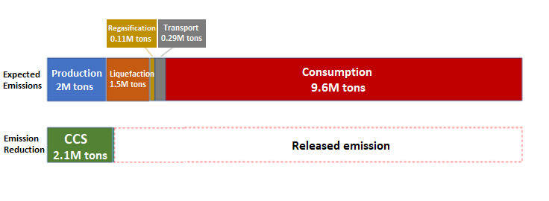
Estimated greenhouse gas emissions from the Barossa gas project (Source: ERM, 2021)

SK E&S has also touted blue hydrogen as “eco-friendly,” claiming to remove CO2 emissions from its production process. However, according to a Cornell-Stanford study, emissions from blue hydrogen are only 9-12% lower than that from grey hydrogen.

“Language, such as ‘eco-friendly’ and ‘carbon-free,’ while omitting information about carbon emissions from its gas-based hydrogen production process, can be considered false advertising,” added Jihyeon Ha, legal officer at SFOC.

“SK E&S’s attempt to greenwash its fossil fuel business is disappointing, particularly considering that SK Group has heralded itself as an ESG leader in South Korea. SK should withdraw from its fossil gas project and transition to the sustainable energy sector if it really takes its ESG initiatives seriously.”

ENDS.
Solutions for Our Climate (SFOC) is a South Korea-based group that advocates for stronger climate change policies and transition towards a fossil-free society. SFOC is led by legal, economic, financial, and environmental experts with experience in energy and climate policy and works closely with policymakers.

For media inquiries, please reach out to:
Euijin Kim, Communications Officer, Solutions for Our Climate
euijin.kim@forourclimate.org | +82-10-9393-3498

