PRESS RELEASE
Steel industry a major roadblock for South Korea’s green future

South Korea’s climate policies must introduce new decarbonizing technologies for the steel sector to remain competitive for the transition to a low-carbon economy.

March 11, 2022 – Carbon neutrality will be unattainable for South Korea if the government does not facilitate decarbonization for its steel industry, Solutions for Our Climate (SFOC) said today in its joint GCAM-KAIST 2.0 study. Steel represents the most emissions-intensive industry and South Korean policies lag other advanced economies. On top of rising carbon costs, the country risks worsening its climate records—with already the second highest coal power emissions per capita in the world.

In the 28-page study based on the Global Change Analysis Model (GCAM), the Korea Advanced Institute of Science and Technology (KAIST) and SFOC found that the South Korean government’s current policies ensure the country will fail to meet both its 2030 Nationally Determined Contribution (NDC) and its long-term goal of carbon neutrality by 2050. The report analyzed greenhouse gas (GHG) reduction pathways, linking economic activities to GHG emissions for South Korea’s steel industry.
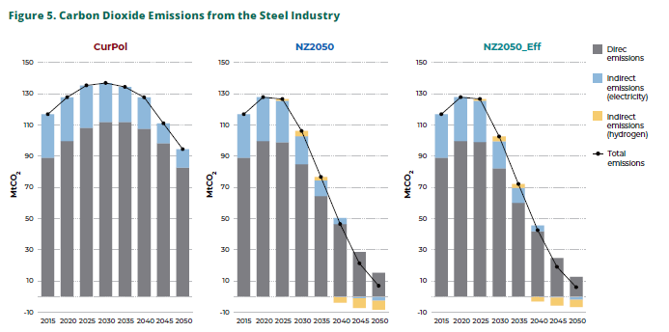
“Carbon neutrality will virtually be impossible for South Korea under its current policies with the steel sector expected to produce over 90 million tons CO₂eq of GHG emissions by 2050,” said Geunha Kim, researcher at SFOC.

South Korea is the world’s fourth largest steel exporter and the highest producer of steel per capita on the planet. Nevertheless, South Korea is falling behind other developed economies, including countries in the European Union. Since last autumn, EU member states accounted for 42% of the world’s newly announced low-carbon steelmaking projects.

Steel production is highly energy-intensive and requires consuming energy from fossil fuels such as coal and gas. South Korea’s steel industry is the largest emitter of GHGs in the industrial sector, accounting for 39% of all industrial GHG emissions and 13.1% of the country’s total GHG output in 2018.

“South Korea will need to quickly facilitate decarbonization, phasing out conventional blast furnaces, which use fossil fuels, and introducing electrification and greater use of green hydrogen as energy,” Associate Professor of KAIST College of Business Jiyong Eom said. “This requires greater long-term investments aimed at increasing renewable energy power generation.”
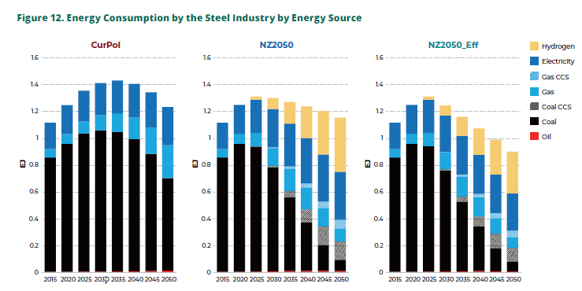
The study revealed that if the South Korean government does not push for the immediate adoption of next-generation technologies, such as hydrogen reduction steelmaking and Carbon Capture & Storage (CCS), South Korea’s present policies would only decrease GHG emissions by 1% on average each year until 2050. Under those guidelines, carbon neutrality will be out of reach for South Korea as the steel sector’s coal use must fall by 80% between 2020 and 2050.

“Climate policy-driven decarbonization of power generation and an enhanced NDC is imperative to achieving carbon neutrality,” said SFOC’s Kim. “If new technologies and increased renewable energy generation are not adopted in a timely manner, South Korea will fail to remain globally competitive.”

ENDS.

Solutions for Our Climate (SFOC) is a South Korea-based group that advocates for stronger climate policies and reforms in power regulations. SFOC is led by legal, economic, financial, and environmental experts with experience in energy and climate policy and works closely with policymakers.

For media inquiries, please reach out to:
Joseph Kim, Communications Team Manager, joseph.kim@forourclimate.org

